Adding New Pages and Database Backend

Christine Hodges

Rasmussen College

Author Note

This paper is being submitted on April 22nd, 2018 for Professor Darice Corey’s CIS3801 Fundamentals of Mobile Web Application Development Course.

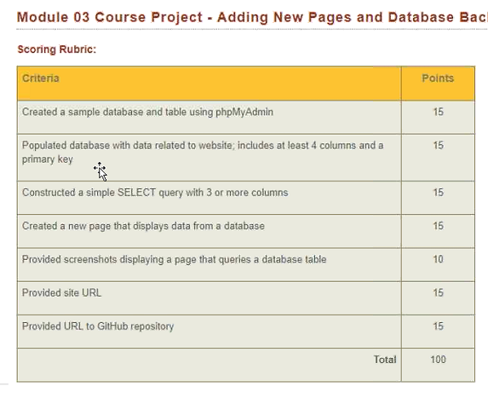

Based on the type of website you’ve created for your project, you must create a new web page that displays the content of a database. You must complete the following tasks:

2. Populate database with data related to website, includes at least 4 columns and a primary key

* Create a sample database and table using phpMyAdmin in your Microsoft Azure account.
* Populate the database with data that is related to your website. This must include at least 4 columns, including a primary key.
* Construct a simple SELECT query with 3 or more columns.
* Construct a web page with responsive styling that displays the results of a query.

1. Create a sample database and table using phpMyAdmin in your Microsoft Azure Account

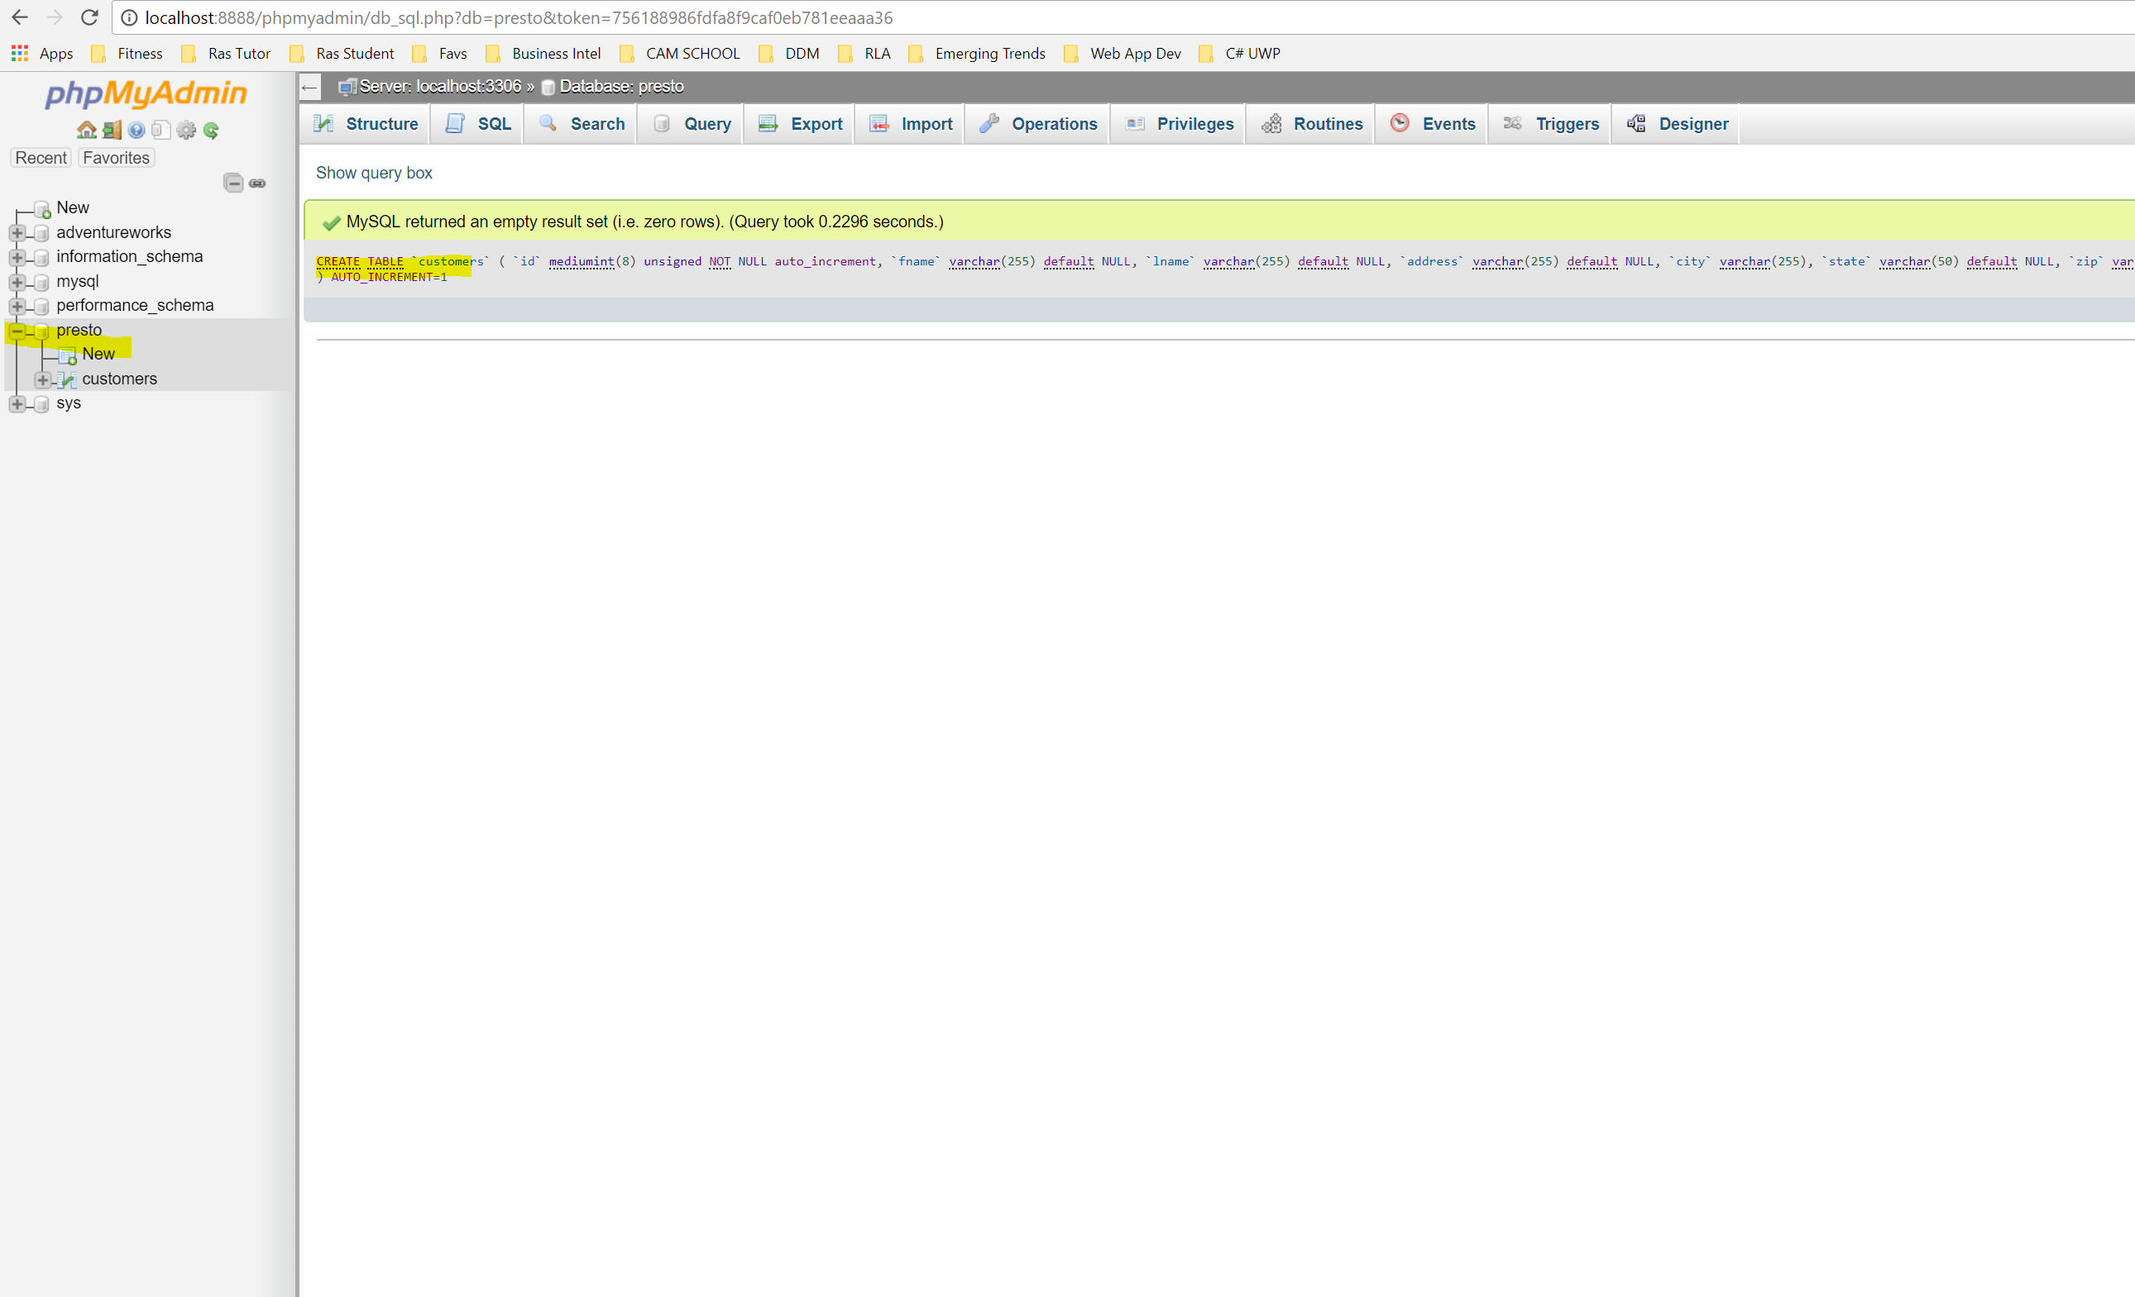

2. Populate database with data related to website, includes at least 4 columns and a primary key

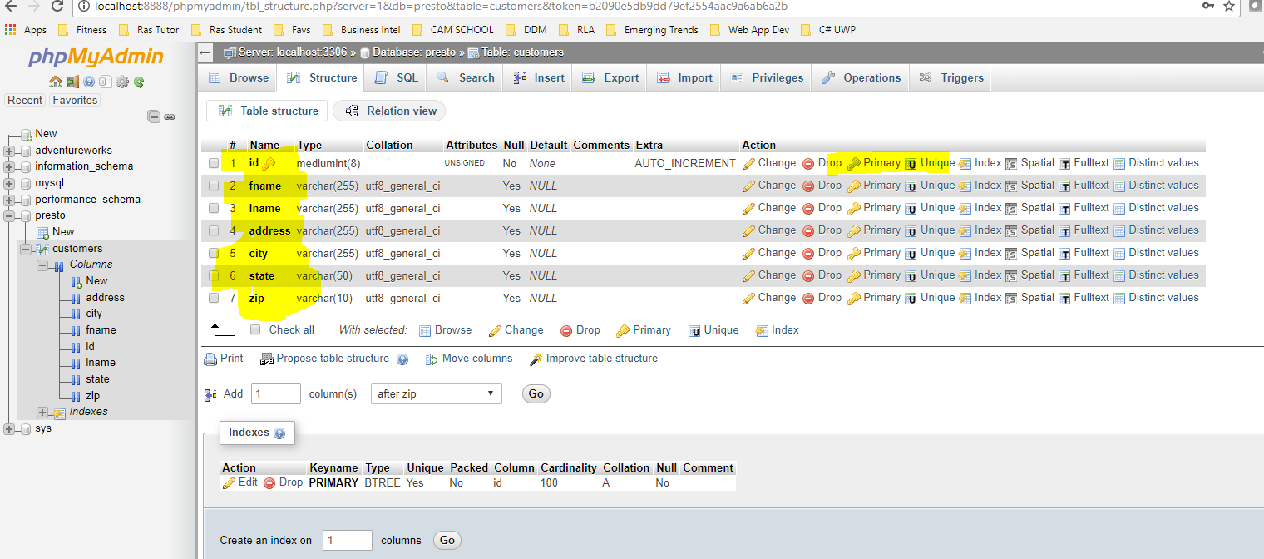

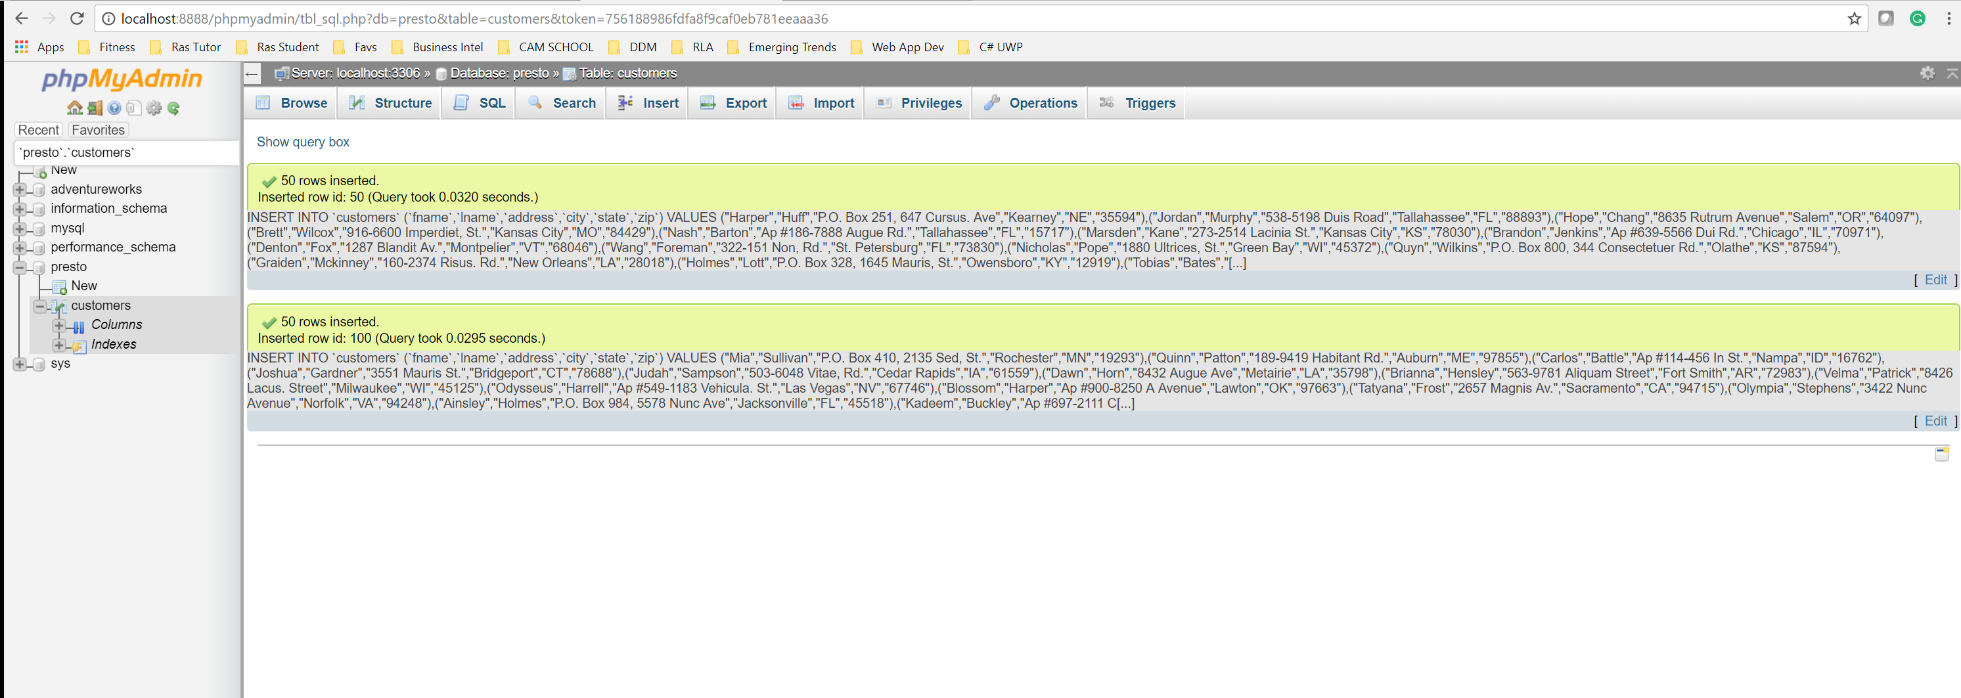

3. Construct a simple SELECT query with 3 or more columns.

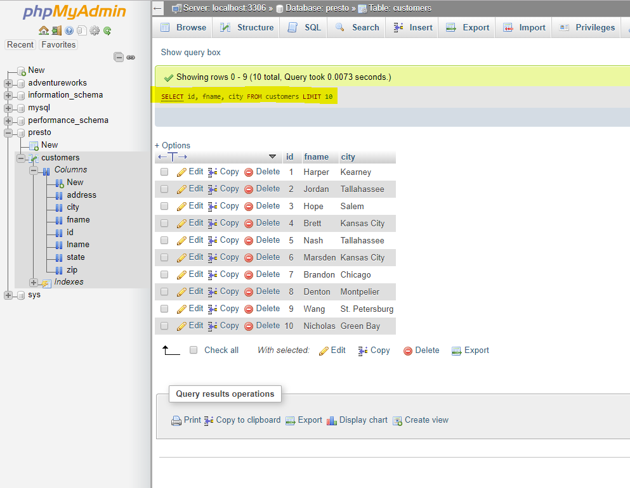

Construct a web page with responsive styling that displays the results of a query.

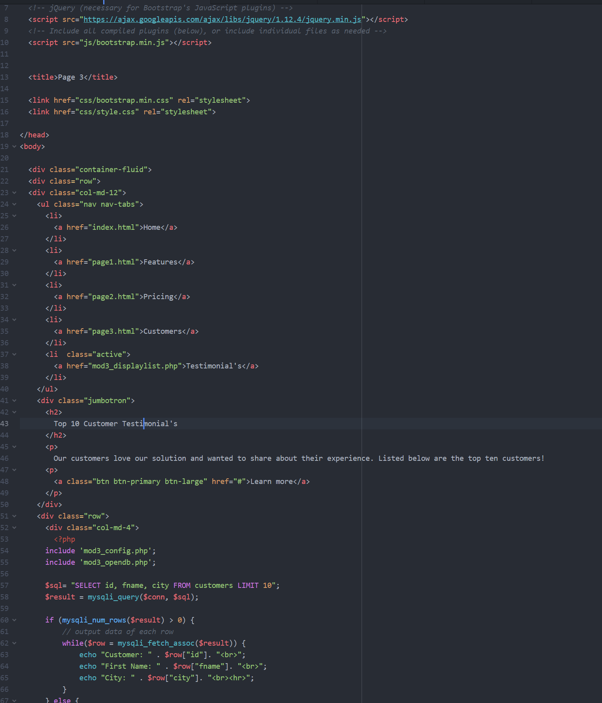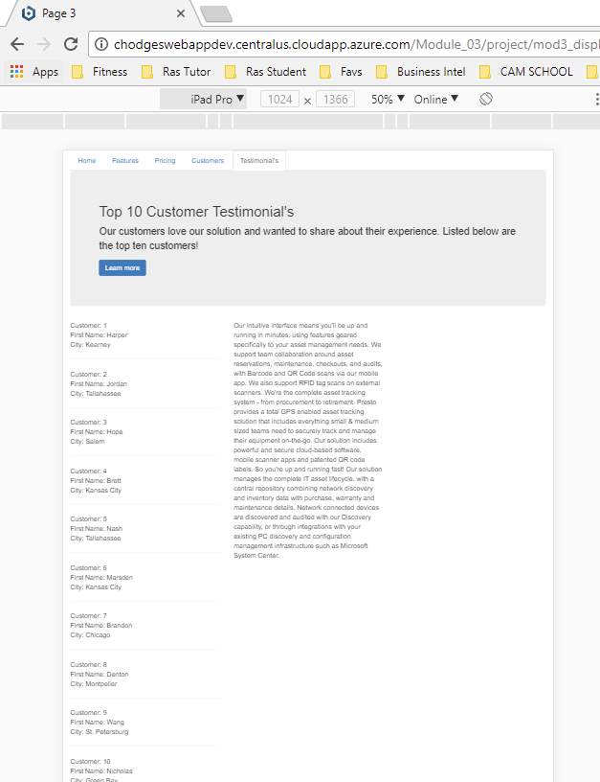

A Microsoft Word document containing your name, the module and assignment name, description of your site, and your site URL, such as:   
  
Home: <http://chodgeswebappdev.centralus.cloudapp.azure.com/Module_03/project/index.html>

Features: <http://chodgeswebappdev.centralus.cloudapp.azure.com/Module_03/project/page1.html>   
  
Testimonial’s (Displays list): <http://chodgeswebappdev.centralus.cloudapp.azure.com/Module_03/project/mod3_displaylist.php>

* The URL to your GitHub repository, such as:   
    
  <https://github.com/fitactivemomgineer/Module3CourseProject>

Screenshots displaying a page that queries a database table. This must use a sample table that you’ve created.

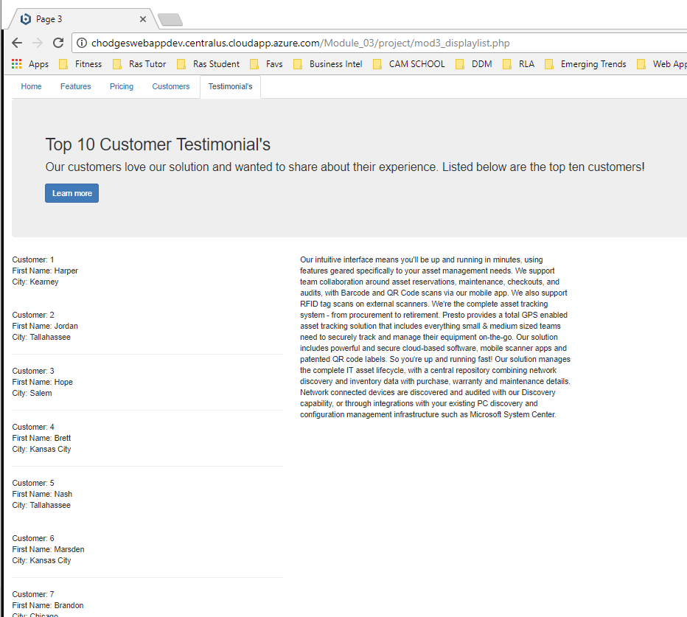  
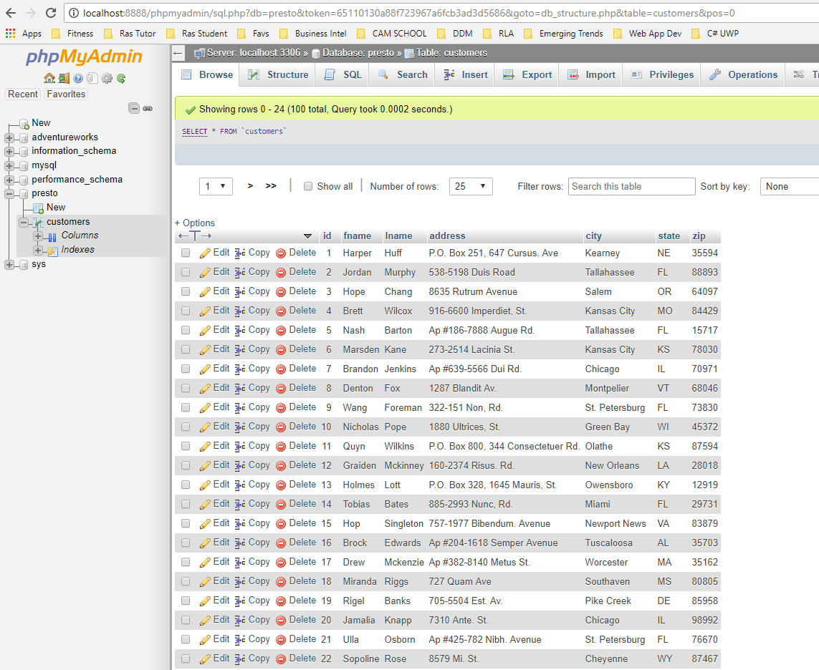

The screenshots must display at least 2 different screen sizes, such as desktop and mobile displays.

